**An Introduction to Modern Software Quality Assurance**

***Alishba Arshad ,Sufiyan Irfan , Wajahat Ahmed , Rehan Mumtaz, Kabeer Ahmed***

*Department of Software Engineering*

*NED University of Engineering and Technology, Karachi, Pakistan*

***Abstract –* Software products are not built overnight. It takes a lot of effort, team coordination,development and testing to come up with a final version of the product. Regardless of the software product, its complexity or size, the purpose of QA remain same; to reduce the defects to minimum to ensure minimum disruption.This paper is written to propose modern practises for carrying out quality assurance .This research paper solely focuses on how the older methods have been evolved into the new frameworks and models to adapt to the new trends of SDLC .It discusses how these methods are carried out for evaluation of quality and other prominent factors within and throughout the development life of a software and the resulting product thus leading to better customer and managerial satisfaction at both product and process levels. However, with each of the proposed modern methods ,there are some limitations that may vary with the nature of projects. In this paper we describe the limitations of each of the method followed by the comparison with other tools and elaborate when considering the use of a specific tool might be the best choice for us .It also describes the scope of the work that is yet to be discovered and carried out to cater to limitations and disadvantages of the described modern frameworks and models at both general and personal level.**

***Index Terms*— Quality,Agile,sigma ,Devops,Spice,modernization**

1. **INTRODUCTION**

Software Development tends to increase with the days passing through as the world is shifting towards digitization as the demand for software developers increases accordingly, as every business is coming with their new product in the market nowadays. However, products reaching faster in the market does not guarantee faster growth but the error free/ efficient product does matter. Here comes the part of quality assurance in play, that is there to manage all the processes in the best efficient way possible, tracking the progress and making sure the product is delivered on-time and everything should be done under budget, with no compromise over quality & getting the consumer satisfaction. **[1]** Many businesses are approaching the QA process from a perspective of digital transformation, ensuring that their activities are aligned in order to formulate a more cohesive strategy. The end goal is guaranteeing continuous delivery and high-quality products, as well as a more efficient process.

It’s probably clear by now that development and testing aren’t distinct — they go hand in hand and are both integral to the SDLC. Nor are they separate phases of a software project. Because of this, businesses are recognizing that QA testing must start early on before there’s time for defects to fully materialise, which makes them more difficult to address.Quality assurance isn’t an afterthought when it comes to software development. As we move into a new era of technology, priorities are changing. Businesses are looking to develop the best products to earn them a strong reputation — and they are realising that QA testing is a large part of the answer.

In recent years, because of market demands, manufacturing companies now have to satisfy customers' increasingly broad and continual demands. The pursuit of a high degree of quality has evolved into one of the core strategic and operational goals of contemporary organisations. Businesses must compete in the area of quality management if they want to be among the best. It concerns: workplace quality, the entirety of the information management, design phases and technical components, as well as personal quality whilst also generating final products in stages, and bearing in view that quality should be acquired at every stage of production throughout in order to meet the requirements of the final product.

Since the last decade, there had been rising in the new methods in the market for quality assurance that had come for the takeover of the traditional methods that are still in use in some organisations, traditional methods have become obsolete due to the latest technology in the market that is not able to satisfy the effectiveness of the software product. This paper mainly describes the comparative approach between the traditional methods which were being followed and now what are latest in use in tech firms, which reflects growth of their product.

Contents are managed as, next section [II] points the related work, section [III] explains methodology. As section [IV] explains the limitation [V] for Future work. Section [VII] discusses the conclusion

1. **RELATED WORK**

DAVID GELPERIN and BILL HETZEL published research on “The growth of software testing industry” and how the software testing shifted from being a sequential phase done at the end of the project to a parallel track executing and affecting each phase of the life cycle. The authors describes the evolution of models when the testing perspective changed from “debugging ie checking the program” to “making sure it runs” then “intent of finding defects” and finally to the evaluation oriented period where the QA process applies to each phase ,preventing the downflow of errors and ensuring that the project meets not only the quality goals but the managerial goals as well. It also evaluates the performance of the former manual processes and the newly proposed software quality models like STEP and FURPS and concludes on various statistical results that the evolution of the methods of SQA has generally improved in terms of cost time and efficiency leading to better quality products and increased customer satisfaction[2]

This was further elaborated in detail by Abhiup Sinha, Pallabi Das who presented a comparison between how quality assurance is done in different sdlc models and how agile methodologies are better than traditional methods for ensuring quality of a product [3]. In traditional waterfall lifecycle quality is assured at the end of each phase or level so we cannot check the quality at the middle of any phase whereas in agile methodologies process is divided into shorter cycles called (sprints or iterations) and testing is done in parallel with the development phases like requirement gathering, planning, designing, coding, test case preparation and execution. Agile methodologies like scrum, extreme programming are iterative in nature means change in requirements can be verified and validated whereas traditional methods cannot cope up with the change in requirements.

The creation of software products frequently makes use of established software processes like the Software Development Lifecycle(SDLC). There have been various models for dealing with these sorts of cycles, and each illustrating a different method for handling the various events or actions carried out throughout the process. Agile approaches, according to the paper's author[4], are good techniques that seem to be a response to frequent market changes and show important strengths of the scrum methodology, including its idea of a quick development cycle, high level of customer satisfaction, and quick change adaptability.Every issue influencing SQA procedure was investigated in this article, and all possible solutions have been offered. The findings of this study may be relevant to practitioners in evaluating certain measuring instruments and application quality attributes.

The work took one step forward as [Bilal Gonen](https://ieeexplore.ieee.org/author/37847097100) and [Dipali Sawant](https://ieeexplore.ieee.org/author/37088401389) published a research paper on “Significance of Agile Software Development and SQA powered by automation” . It reflected on the latest trends of agile development and testing and how the automation testing techniques comply with the rapid delivery and customer interaction idea of agile . Automated testing proved to be most beneficial streamlining the execution of test cases and ensuring the quality despite the less time and efforts.This paper also compares the manual and automated techniques and briefly describes the use of KATALON and selenium tools . It also discusses how the automation techniques despite all its allure is limiting and challenging due to training efforts and not usable for the assessment of some quality goals like usability , attractiveness etc. [5]

Taking a practical step ahead with the idea , in the paper [6] Anish Cheriyan, Raju Ramakrishna Gondkar, Thiyagu Gopal, Suresh Babu S. did extensive research about new QA practices and techniques for continuous improvement and delivery of quality products. They proposed the ACID-QA Model short for Agile Continuous Integration and Delivery - Quality Assurance which can be followed by QA professionals to ensure continuous delivery of software. The ACID-QA model is also implemented in the big data domain with promising results of fault detection and quality improvement. In this model, quality conformance is done with pipelining technique means after new code is developed and passed to the configuration library, it goes through various automated tests (unit, functional, regression, integration etc) and different inspections checks (static code check, duplicate and useless code check) are done on it after which it is released into production.

As the technology advanced different quality models were proposed to ensure the quality of both products and processes in the software industry. As of in the research paper [7] the authors explain the different software quality models and their comparative study with complete advantages, and knowledge. When and where any type of quality model to apply depends on the nature of software and the type of company, for small companies the model behaves differently and for large or medium-level companies the software quality model behaves differently, which is discussed here in this paper. The quality models discussed in this paper are 8 with complete comparative studies between them. The models are TQM (Total Quality Model), CMMI (Capability Maturity Model Integration), ISO, Six Sigma, Bootstrap, TRILLIUM (Telecommunications Product Development and Support Capability Model), TICKET(Check Information Technology ), and SPICE (Software Process Improvement and Capability Determination). The paper discusses the expert system technology and SQA Models to show how the expert system can be used to automate the selection and implementation process of these SQA models. Many characteristics are mentioned in the paper which is found from the previous software models and a comparison is done between the previous software models and new additional features on the model in their research with the help of these characteristics.

Aisha Mohammed Elhassan Hamid based her research on how the six sigma method can be easily integrated and implemented in software architectural design, software construction, software quality metrics, software testing for improving quality by eliminating and removing defects. She also explained a framework based on six sigma which is known as DMAIC framework ( Define, Measure, Analyse, Improve and Control ), helpful when the product created from certain processes does not comply with customers expectations. The primary motive of this research paper was to illustrate how adoption of six sigma methodology can help in reducing errors and variations occurring in the product quality. Metrics were introduced to know the efficacy of six sigma applications in improving the quality. In this research first important processes in sdlc are selected and then review and inspection is done to give answers to these questions. In which phases of currently selected processes, six sigma methodology can be easily integrated ? and How can we effectively map DMAIC phases with the predefined processes ? [8]

However Crossfield and Dale [9], mentioned the capability of using professional systems in total quality management (TQM). According to their study, it was feasible to run expert systems on personal as well as on other computers or systems in an effort to help with components of TQM inclusive of statistical process control, quality costing, items receiving, correct action procedures, dealer (of goods)development, domain failure analysis, and quality function deployment, and that the capable application of professional/experts systems to TQM was received with few degrees of enthusiasm by the person with whom the concept was discussed. It was also pointed out that the most difficult task in producing an expert system is the acquisition of knowledge, and that knowledge elicitation can be facilitated by the use of the quality assurance mapping technique (Q-MAP).

Concluding, A. M. Vollmer and S. Martınez-Fernández explained that software analytics is all about is using data-driven methods to gather pertinent and useful information to support QA with their data-related activities and suggesting the usage of a software analytics platform for QA to manage quality and explore their benefits as the advantage that has the most effect and is the most unique for them, and from modern software analytics platforms the QA can take benefits which the author explore in it.They also hoped to improve their operations by using the data offered by Q-Rapids to make better data-driven decisions.It give the ability to develop quality criteria semi-automatically to aid quality management, product quality and process performance monitoring, and greater knowledge of product readiness[10].

According to a different study, radiation oncology information systems (ROIS) require a systematic and thorough quality assurance (QA) programme to ensure the accuracy of clinical and treatment-related data and to reduce the risk of data loss. Baoshe Zhang & Shifeng Chen came up with their framework of quality assurance for managing critical data in ROIS systems as they stated in their research paper [11], they stated ROISs data falls into five categories and foreach data source there is a respective QA strategy stated by framework for ensuring data integrity. Every piece of information in the ROIS was checked using this method, including the tons of ROIS database records.

These five sources of data and data models are compared between ROIS states as per QA framework's central conceit. A test is run from start to the finish to further analyse linkages and interconnections in between ROIS system and other healthcare settings after data integrity has been confirmed (mainly treatment control,planning, control consoles,& medical sciences information systems)The QA architecture developed in this work been adopted for our mainly ROIS QA, and ROIS upgrade since it has proven to be safe, practical, efficient and thorough without requiring workers manual inspections.

Even though all these researches and work were quite extensive there is no doubt room for much more research to understand how to implement a suitable quality framework in place and more interestingly how much these frameworks will alter with the course of changing technology .

1. **METHODOLOGY**

The SQA team focuses on uncovering the potential defects from a product as well as the process carried out to achieve the good or service. Since the development methodologies have been changing drastically with the changing needs , the testing lifecycle is also adapting to the modernization process. It is far away from the limitations of a single step in the waterfall cycle and has found a home throughout the SDLC to detect errors early and achieve customer satisfaction through early rectification and improved quality.

**III.I. QA MODELS AND FRAMEWORKS:**

Below we state some modern frameworks and methodologies of QA of both product and process levels.

**III.I.I SIX SIGMA:**

Six Sigma methodology uses a set of statistical quality assurance techniques to improve product and process quality and reduce defects incurred during software development . It refers to six sigma because it ensures that any defect if found in a system process or product should lie six standard deviations after the mean. This makes it extremely efficient for mission critical systems.

Six Sigma works by finding the root cause of all likely problems in the system that may lead to defects. Evaluation of these issues are done by trained persons who make the use of six sigma tools to visualise the detail of each operation and why a certain defect may occur.This is usually done by mapping software product and process goals to metrics and evaluating their product score. If the metrics values result are not close to their actual predefined values, there are high chances that defect has occurred. Tracking and monitoring of these metrics can be done for change in values that might show compromise in quality. Root cause analysis is the major task done to determine the process weakness that caused the product defect.

There are two methodologies that are generally used for six sigma. The DMAIC which is used for correcting process defects that exists ; and the DMADV that is used to create a new process or product.The steps for each one are:

**(a) DMAIC:**

**D:** Define product goals , objectives and deliverables.

**M:**  Measure the current state of the system and the inputs or operations that may lead to fault . A baseline is defined to analyse the distance of the system from six sigma.

**A:**  Analyse the root cause of the problems in the system.This is the main process of the entire six sigma process.

**I:** Improvement techniques are suggested and solutions are devised to reduce the defects and improve efficiency of the process/product.

**C:** Control measures are implemented in this stage to ensure that such defects do not occur again.

**(b) DMADV.**

**D:** Define scope , objectives deliverables

**M:** Measure performance and efficiency of the proposed system or process by the defined metrics and implementation methods

**A:** Analyse the risks and likely defects and their causes.

**D:**  Design a process or product that will lead to an effective and efficient process/product that will meet customer requirements and quality goals by proposing solutions for the identified problems.

**V:** Verify at the end of the development process that the goals and performance criteria are met.

***Why Six Sigma?:***

It is better to use six sigma when we require both quality in the process and product. Six Sigma quality control helps in finding those areas which need improvement. It not only identifies a problem in the process or product, but also comes up with viable solutions and monitors the whole implementation process. The main advantage of using six sigma for quality control as compared to other methods is that this methodology is customer oriented and main focus is to fulfil customer demands. It is a proactive technique rather than reactive, as this method can determine how improvements can be made even before faults or defects are found.

**III.I.II. AGILE:**

Agile is a software development methodology process based on iterative and incremental development and delivery of software. In the incremental process, mostly software is built block by block in phases or iterations, allowing the quality assurance engineer to ensure and test quality of the system at each level or phase. Modern software development opts for Agile lifecycles and enable faster development and delivery by integrating development and testing together from the start of the project.

In agile , working software is prioritised over documentation so detailed test cases aren't required. This shifts the entire process of QA into four cycles:

*1-Initiation Phase:*

The SQA involves deciding the testing tools , people and scheduling resources.In this step in agile process the scope , key requirements , risks , cost and estimates are defined and the SQE aims to verify and validate each one of them to dissolve ambiguities.

*2-Construction Iterations:*

It consists of a set of iterations to develop the software . In each iteration ,the most essential and available requirements are selected, implemented and tested. The testing is done in two ways:

1. Confirmatory testing:

It aims at determining that all the requirements of the customers are met and conforms to the organisation’s quality standards. It ensures that all the deliverables are provided to the customer on date as they have expected

1. Investigative Testing:

It aims at finding the potential problems of the system that the confirmatory testing may have skipped in the form of defect stories and then analyse them to find their root cause. It mainly focuses on testing systems for security , integration and load. It also

*3-Release:*

In this phase the QA process includes user acceptance testing by involving both the stakeholders and the testers and testing the system as a whole.

*4-Production:*

In this phase , a system is deployed . Here deployment testing is done and the performance is measured to ensure the quality meets expectations.

Some agile methods involve daily refactoring and builds after reviewing the latest iteration results with all team members and stakeholders involved. Some also do early preparation of test cases based on the user stories created in the early stages of development. Since rapid delivery is the key , automated testing should be done wherever possible.[12]

***Why Agile?:***

When we have to deliver a quality product in a short period of time Agile quality models are the best as less documentation is required and QA specialists do not have to waste time in writing long test cases, reports and summaries. Rather focus is on building a product of high quality. One key benefit of using agile methodologies like scrum, kanban, and extreme programming is it saves financial resources and time. In this method testing is done in parallel with development and in each iteration early detection of bugs and errors is possible. So the team doesn't have to redesign the whole process. Also in agile rapid feedback from customer is received and changes can be applied easily so product remains in a consistent state and a final product of high quality is developed

**III.I.III. DEVOPS:**

The Devops methodology in development brought one step forward to agile development by bringing continuous integration and continuous delivery. Here the testing is not the responsibility of one individual and is distributed among developers, testers and operations and thus done continuously. The code is integrated into a single repository where automated testing is done through tools like KATALON , SELENIUM etc.

The process of QA in devops is selecting the tools and resources for testing . Deciding who will test what and creating an automated pipeline for testing so that the code integrated can be tested and pushed to production faster. Where automation is not possible , pair testing is done and all the bugs reported are made live on a reporting platform so that the whole team is aware of the issue.[13]

***Why consider DEVOPS?:***

DevOps methodology is suitable when the project goal is to ensure both quality and speed in the development process while automating the process of delivering the software and making changes in the infrastructure. Quality assurance is done all through the testing and delivery cycle and both the teams of testing and development are responsible for it. In DevOps quality creep comes at every level. The main approach to use DevOps is to have better and improved communication and collaboration between the developer, tester, and operations teams, so they can work together as a team to produce high-quality product

**III.I.IV. SPICE:**

SPICE is an abbreviation for Software Process Improvement and Capability Determination model. It is a framework which measures the quality of software processes. It analyzes the tools , methods and techniques used to develop the software and suggest improvements for them[14] .It involves the following steps:

*1- Process Assessment:*

This includes the measurement of effectiveness and efficiency of the software processes and how they are used to meet the user specifications. It also involves the detection of risks , problems and strength of a particular process and how they affect the development of a product.

*2-Capability Determination:*

This involves the analysis of the potential of the process and to what benefits it brings to the organisation and whether it can be improved and tailored to meet specific needs. The process is labelled into one of the five levels(performed,managed,established , predictable and optimised ) according to the maturity and performance of the process[8]

*3-Improvement:*

It determines what changes can be made to the current process to improve its performance and reduce the risks and weaknesses of it.

**Why SPICE Model?**

The SPICE standard defines a method for measuring process capabilities and describing the recommended order of activities in a software development project. While doing so, it stays away from a particular improvement strategy found in other models, like CMM ( Capability Maturity Model ) . The management and process defining structures of an organisation are highlighted by SPICE.

The main objective of SPICE is to assist businesses and software development teams in process improvement based on exact definitions of the goals and initiatives needed to achieve these goals. Software providers, purchasers, and assessors all benefit greatly from it.

**III.I.V. TOTAL QUALITY MANAGEMENT:**

TQM similar to Six Sigma approaches to find defects in the system by streamlining the process of manufacturing softwares through improved customer satisfaction and experience.It works on both process and product level with the belief that the customer satisfaction can be increased through proper management techniques and if every individual work towards improving the process tasks and activities involved in the process.[15]

The principles of TQM are:

1-The evaluation of quality is finalised by the customer and he decides on the overall quality of the product.

2-All employees are included in the quality management.

3-It focuses on the processes and activities carried out to develop the product .

4-Since it focuses on managerial efforts to obtain quality, strategic planning and thinking is involved.

5-It gives importance to effective communication as all the employees are a part of the quality management process.

6-It aims for continuous improvement and enhancement of process.

7-It gives importance to decision making on facts and collects and analyzes data for that purpose.

TQM improves the quality of work in the organisation and benefits in following ways:

* **Reduction in defects :** TQM benefits with its capability of executing high quality products and services within the specified time .It uses such methods that reduces the amount of defects in the system reducing product recalls and fixes.
* **Stakeholder satisfaction:** It helps in meeting high customer expectations and thus greater reach in the market. This can result in a sales boom through upsell and marketing initiated through customers using simpler means such as word of mouth.
* **Less expenses:** The result of much less product defects leads to decrement in organisations product replacements and amount of product fixes that not only improves customer satisfaction but also result in lower cost and high revenues
* **Cultural values:** Organisations opting TQM expand and nurture values in the organisation such as discipline , close coordination and a sense of non-stop improvement. It stresses the responsibility of quality to the whole organisation and hence improves their coordination and relations.

**Why TQM Model?**

On the growth of employees and organisations, TQM can create a huge and positive impact. By having all employees focus on quality management and continuous development, businesses can create cultural norms that produce long-term success for both clients and the company.

**III.I.VI. CMMI Model:**

It is an improvement framework for the processes being used in the organisation for the development of software products [13]. CMMI enables combining historically separate organisational functions, set technique development dreams and priorities, offer steerage for high-satisfactory methods, it also gives an attribute for new processes to rate. Some CMMI models are derived from this framework (CMMI Framework). Two types of ways for presentation in these models, these are called continuous and staged. It analyses the maturity of the organisation according to the state of their processes and categories them to five levels.[16]

*1-Initial:* Processes are not managed properly resulting in possible unpredictable results. Here the quality is low as there are lots of risks involved.

*2-Managed:*The quality of processes is maintained by proper management and implementation according to the specification . Here the risk is less and quality is better.

*3-Defined*:The process conforms to the standard tools and procedures.Medium quality and risk

*4-Quantitatively Managed:* For this purpose we develop and design metrics for judging the effectiveness and quality of the processes according to specifications. Low risk is involved.

*5-Optimised:* Improvement steps and introduced in the process where needed in an incremental approach . Lowest risk is there.

The benefits obtained from using CMMI model in process improvement are:

1. Less rework and defects due to the reuse strategy. This helps it become cheap and efficient
2. More productivity and time efficiency
3. Increases the probability of stakeholder satisfaction
4. Increases revenue and returns on investment

**Why CMMI Model ?**

It raises the quality of delivered software. Increased customer satisfaction. It assists in accomplishing specific cost savings goals. Additionally, the model guarantees consistency in high performance and stability.

**III.II. COMPARATIVE STUDY OF SQA MODELS:**

In order to investigate their quality models, many software firms are finding themselves in a situation where they must combine two models or use more than one evaluation/assessment model. The cost of conducting business is increasing as a result, but this can be reduced by understanding the overlapping of assessment models and how they differ from one another [17]. The aim of this research is to simplify the evaluation of SQA models and to clarify their objectives for software development companies so that they can adopt the SQA models that are most suited to their characteristics and requirements. For software firms, especially small and medium ones, the effective selection and implementation of these models is frequently a challenging and expensive undertaking.

List of 30 features or areas of interest were given, important for analysing similarities and differences and across SQAmodels after a thorough comparison of the aforementioned models and improvement of the aforementioned previous work, analysis and research of the aforementioned models[18][19]. Because there are too many qualities, we have divided them into 5 groups. As shown below, the comparison study used in this research includes both a detailed written description outlining the benefits and drawbacks of each model as well as a tabular list of 30 proposed features for the six SQA models. The proposed 30 qualities, which include novel features from this research as well as earlier relevant work on model comparisons, are briefly described in the section that follows.

First one is the C1 category named General Category shows the properties of quality models on the basis of their development, this category contains these attributes, geographic origin, scientific origin, development, popularity, software specific, descriptive , scope and adaptability.

Second one is the C2 category called Process Category which shows how to use the software quality model. This category contains the following attributes: assessment, assessor, improvement initiation,process improvement method, focus on improvement, analysis technique, documents for evaluation, requirement management, managing of documents.

Third category is the C3 category known as the Organisation Category which explains the properties of the company and environment in which the SQA model is implemented. This category holds these attributes, actors/stakeholders, organisation/ company size, coherence.

Fourth category is C4 category which is called Quality Category, it describes how the quality is achieved using a particular SQA model, this category has following attributes, Quality perspective, Progression, Causal relation, Comparative, Result Category, Goal, Process Artefacts, Certification, Cost of Implementation, Validation, Integration Ability.

**SQA Models for processes’ Comparison [TQM, CMMI, SPICE and Six Sigma].**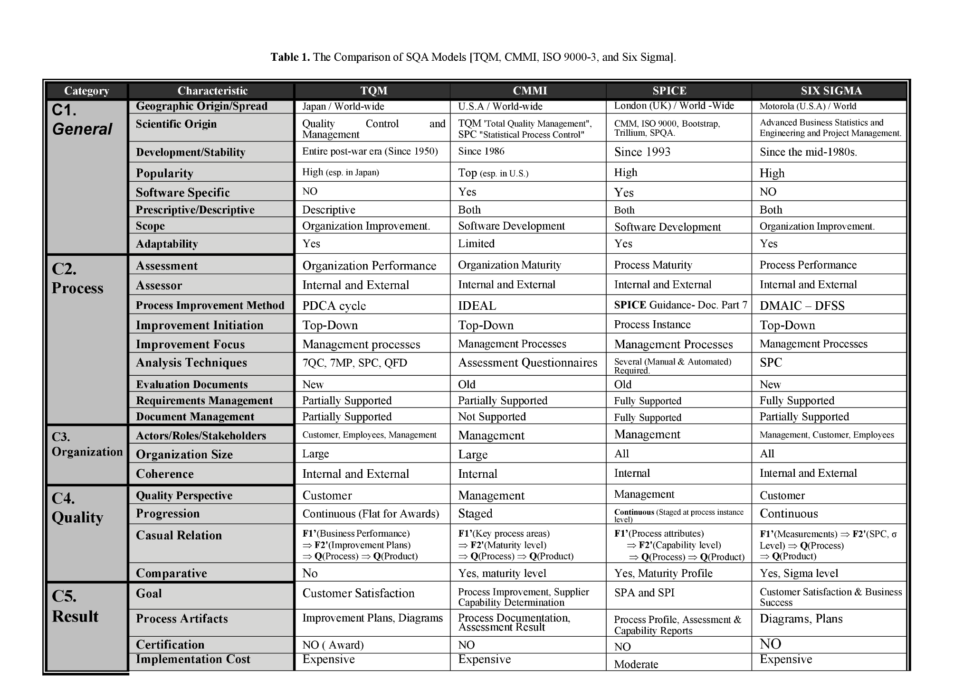



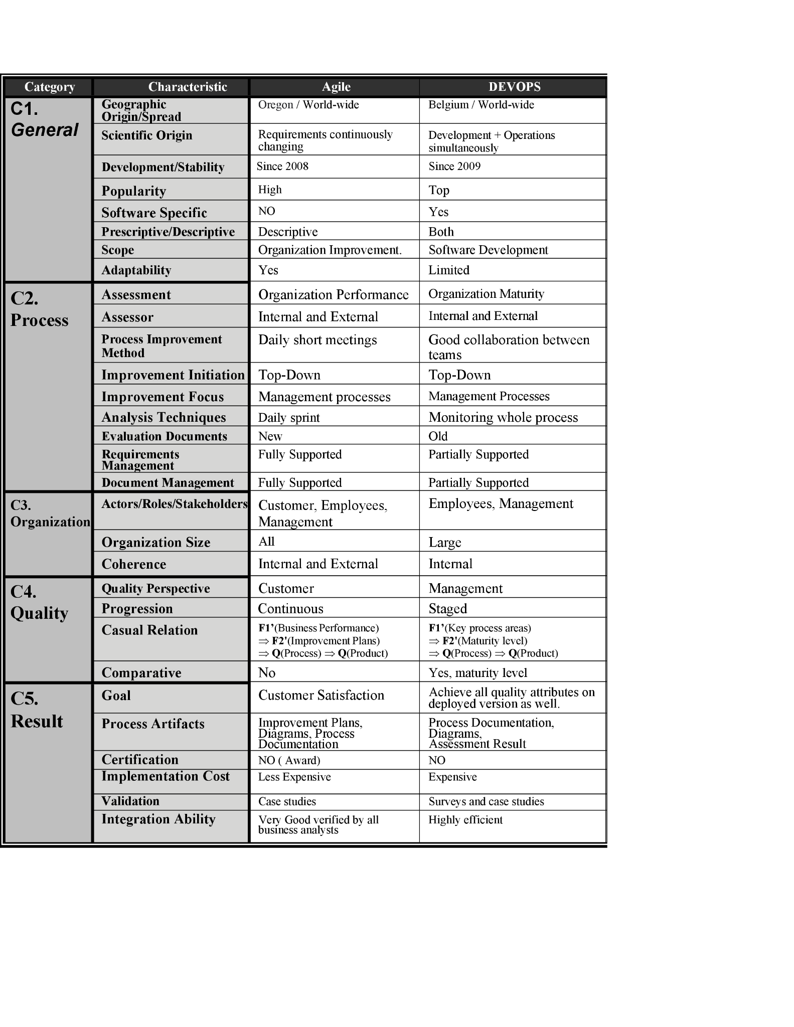

**SQA Models for processes’ Comparison [Agile, Devops].**



1. **LIMITATIONS**

There are numerous benefits to modern QA but each approach comes with certain tradeoffs and concerns:

The Six Sigma approach explicitly defines the quality achieving methods to be used . It doesn't allow flexibility to include other tools and methods into the plan making it a rigid model which is too complicated and expensive to use it on daily routine projects. Some developers fail to make the connection between process and product improvement by reducing the points where defects are injected into the product.

The devops and agile methodologies however decrease latency and incorporate more frequent deliveries. However these approaches do not work where there is no need for quick deliveries or there are less deliverables. They are also difficult to implement where legacy systems and processes are in place so the testing by these methodologies do not produce beneficial results in this case. Moreover as the devops make the use of automation tools it focuses more on the reusability of the design rather than the aesthetics, usability. So the designs are not proved to be correct even if they are tested properly with these methods.

Accustomed to change, the agile model presents difficulties when users are not completely aware of the final product they want and hence it is not suitable for testing those projects who do not have a clear picture of the final outcome using agile. It also imposes some difficulties to calculate the efforts required during testing if the project deliverables are large. The agile methodology focuses less on the documentation so it is not suitable for it to be used in the maintenance and its testing .[20] The same limitation applies to the CMMI model where we observed that processes with poor documentation rarely reached the high maturity stage.

The CMMI model presents different limitations .It is not suitable for every organisation . The maturity level may be increased quickly for smaller organisations but for those having bigger workflows and large infrastructure incorporating CMMI may be a tedious task . Moreover, it requires a lot of focus and dedication as the users tend to become more fixated on reaching the next maturity level and forget about achieving the big picture " high quality process". For this reason, it stresses upon the untested assertions that proper management is necessary for the quality process , and as the whole process improvement plans and strategies to reach high maturity level are based on opinions , the whole quality software process is just experts opinions and calculated guesses which may also be ambiguous.[21]

The SPICE model for the software quality process is too general in nature. They visualise the basic structure of the process irrespective of the domain and provide insights to it . This is not sufficient and valid as processes during implementation are more complex and detailed as compared to the some aspects considered during the process improvement process.

Along with the limitations to specific methods there are some limitations that apply to whole modern QA processes in general.

*(i) Unrealistic expectations from automation:*

Modern QA gives significance to the use of automated tools but it must be realised that they can be implemented everywhere. Compatibility and Usability are best off with manual methods and cant be tested correctly with automated scripts .A proper balance thus should be maintained between automated and manual methods to ensure the best quality product.

*(ii) Proper Training and use of tools:*

Even though the modern tools come with great benefits the improper use of the tools may give erroneous results and it would seem as if it meets the quality requirements while being a defective process or product . So proper training , use and planning of the tools is required.

*(iii) Additional costs and resources:*

The traditional methods offered a slow and lengthy process of QA however incurred small costs and resources . The improper use of QA tools may lead to wastage of resources and it is a huge loss as they are quite expensive. Moreover the modern QA tools shouldnt be used for one time testing as it will provide more expense and test cases as compared to traditional methods. So the selection of tools and proper planning of SQA is important.

*(iv)Complexity:*

The Modern QA methods are generally complex and hard to understand. The concept of six sigma relying on the statistical methods needs fairly trained individuals to make proper use of the technique. In the same way , CMMI and TQM are a success when each individual contributes to the general quality workflow decided by the management to contribute to the quality of the process. So each person requires proper training and understanding of the tools and techniques that are decided to be used .[22]

1. **FUTURE WORK**

Practically every part of our life, from work to shopping, is being impacted by artificial intelligence (AI). So it comes as no surprise that AI is also playing a significant role in QA testing.Although the application of AI in testing is still in its relative infancy, it is now obvious that ML algorithms and AI may make it easier to create superior test cases, report results, and do much more. It will enable QA testers to find flaws and pinpoint problem spots that the human eye might miss.

Additionally, because AI agents are capable of self-learning and development,Without assistance from a human, they adjust to changes in the codebase and find new application features during testing. To help ongoing testing efforts, QA teams might use AI testing technologies and get the best test coverage quickly and accurately.The testing tools, which enhance tests with AI-powered visual verifications and produce a variety of diverse results, are another example of how AI is used in automated quality assurance.

1. **CONCLUSION**

Modern SQA is the byproduct of the mixture of several disciplines:First, the body of quality assurance produced over the previous century for business and industry.Second, more recent work on software development process maturity and associated testing maturity models.Third, the formation of various formal quality standards like ISO/IEC:25010. We developed useful quality models that can be applied to and carried out in operational contexts via conversations on what quality is and how it works, the fundamental principles of SQA are explained. The ideas of "good enough quality" and continuous quality are debated today along with the more formal standards.These guidelines are related to recent studies on software process maturity models and testing maturity models, as well as how these ideas fit with the modern Agile, DevOps, and other development paradigms.the creation of metrics to assess the effectiveness of testing and other quality activities in order to introduce improvements to the testing process. Software quality control ponders how we transform the requirements for software quality into particular testing goals, methods, and processes, as well as how testing efforts are evaluated and modified to achieve the quality goals.

1. **REFERENCES**

**[1]** *M. Lochan, "Elevating Software Quality Role Using Angle Methodology," 2021 International Conference on Technological Advancements and Innovations (ICTAI), 2021, pp. 576-581, doi: 10.1109/ICTAI53825.2021.9673334.*

**[2]** The growth of software testing by DAVID GELPERIN and BILL HETZEL

**[3]** Abhiup Sinha, Pallabi Das. “Agile Methodology Vs. Traditional Waterfall SDLC: A case study on Quality Assurance process in Software Industry” 2021 5th International Conference on Electronics, Materials Engineering & Nano-Technology (IEMENTech)

**[4]**  M. Lochan, "Elevating Software Quality Role Using Angle Methodology," *2021 International Conference on Technological Advancements and Innovations (ICTAI)*, 2021, pp. 576-581, doi: 10.1109/ICTAI53825.2021.9673334.

**[5]** Significance of Agile Software Development and SQA Powered by Automation by [Bilal Gonen](https://ieeexplore.ieee.org/author/37847097100) and [Dipali Sawant](https://ieeexplore.ieee.org/author/37088401389)

**[6]** Anish Cheriyan, Raju Ramakrishna Gondkar, Thiyagu Gopal, Suresh Babu S. “Quality Assurance Practices in Continuous Delivery - an implementation in Big Data Domain” 2018 IEEE 8th International Advance Computing Conference (IACC)

**[7]** Software quality assurance models and expert systems by Mohamad Abbas Shouman, Khalid Ali Eldrandaly and Alshaimaa Adel Tantawy

**[8]** Aisha Mohammed Elhassan Hamid “Application of Six Sigma Methodology in Software Development”

**[9]** Crossfield, R. T., Dale, Barrie G., "The use of Expert Systems in Total Quality Management: An exploratory study", Quality and Reliability Engineering International, vol. 7, pp. 19-26.

**[10]** A. M. Vollmer, S. Martınez-Fernández, A. Bagnato, J. Partanen, L. López and P. Rodrıguez, "Practical experiences and value of applying software analytics to manage quality," 2019 ACM/IEEE International Symposium on Empirical Software Engineering and Measurement (ESEM), 2019, pp. 1-6, doi: 10.1109/ESEM.2019.8870162.

**[11]** Baoshe Zhang, Shifeng Chen, Warren D. D'Souza, ByongYong Yi,A systematic quality assurance framework for the upgrade of radiation oncology information systems,Physica Medica,Volume 69,2020,Pages 28-35,ISSN 1120-1797,https://doi.org/10.1016/j.ejmp.2019.11.024.

**[12]** Agile Software Methodology with Scrum for Developing Quality Assurance System by [Mercurius Broto Legowo](https://ieeexplore.ieee.org/author/37087136258); [Budi Indiarto](https://ieeexplore.ieee.org/author/37087136276) and [Deden Prayitno](https://ieeexplore.ieee.org/author/37087135319)

**[13]** DevOps and software quality: A systematic mapping by [AlokMishra and ZiadoonOtaiwib](https://www.sciencedirect.com/science/article/pii/S1574013720304081#!)

**[14]** Pyhäjärvi, M., "SPICE - International Standard for Software Process Assessment", Seminar on Quality Models for Software Engineering Department of Computer Science University of Helsinki.

**[15]** Peleska, J., Zahlten, C., "TQM Pitfalls - and what to do about them".

**[16]** Carnegie Mellon University Software Engineering Institute CMU-SEI, "CMMI Overview", Pittsburgh, USA.

**[17]** Siviy, J., Penn, M. L. and Harper, E., "Relationships Between CMMI® and Six Sigma", software Engineering Measurement and Analysis, CMU/SEI-2005-TN-005

**[18]** Halvorsen, C. P., Conradi, R., "A Taxiomatic Attempt at Comparing SPI Frameworks", Springer Berlin / Heidelberg.

**[19]** Williams, Ddembe and Kennedy, Michael, "A Framework for Improving the Requirements Engineering Process Effectiveness", Software Quality Journal.

**[20]** Significance of Agile Software Development and SQA Powered by Automation by [Bilal Gonen](https://ieeexplore.ieee.org/author/37847097100) and [Dipali Sawant](https://ieeexplore.ieee.org/author/37088401389)

**[21]** Anish Cheriyan, Raju Ramakrishna Gondkar, Thiyagu Gopal, Suresh Babu S. “Quality Assurance Practices in Continuous Delivery - an implementation in Big Data Domain” 2018 IEEE 8th International Advance Computing Conference (IACC)

**[22]** limitations of software process assessment and the recognition of a required re-orientation for global proces